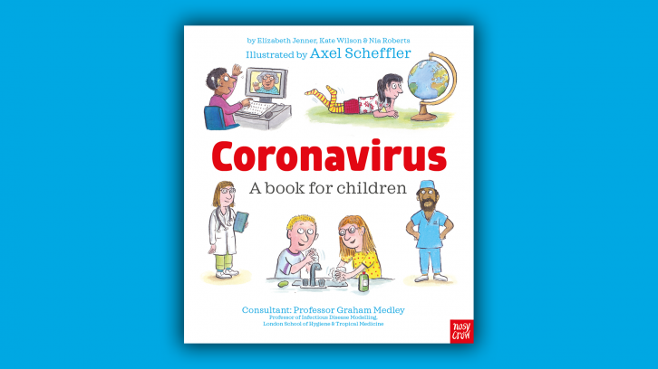

Axel Scheffler has illustrated a digital book for primary school age children, free for anyone to read on screen or print out, about the coronavirus and the measures taken to control it. Published by Nosy Crow, and written by staff within the company, the book has had expert input: Professor Graham Medley of the London School of Hygiene & Tropical Medicine acted as a consultant, and the company also had advice from two head teachers and a child psychologist.
The book answers key questions in simple language appropriate for 5 to 9 year olds:
• What is the coronavirus?
• How do you catch the coronavirus?
• What happens if you catch the coronavirus?
• Why are people worried about catching the coronavirus?
• Is there a cure for the coronavirus?
• Why are some places we normally go to closed?
• What can I do to help?
• What’s going to happen next?
We want to make sure that this book is accessible to every child and family and so the book is offered totally free of charge to anyone who wants to read it.

https:nosycrowcoronavirus.s3-eu-west-1.amazonaws.com/Coronavirus-ABookForChildren.pdf

