Christmas present collection 2023
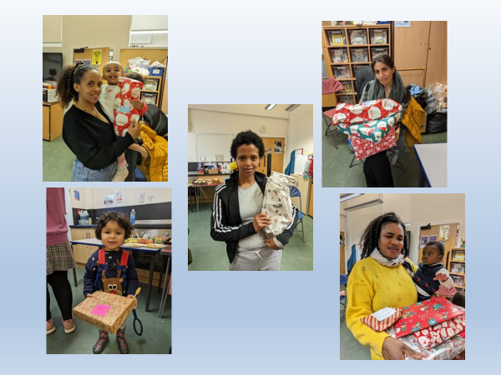
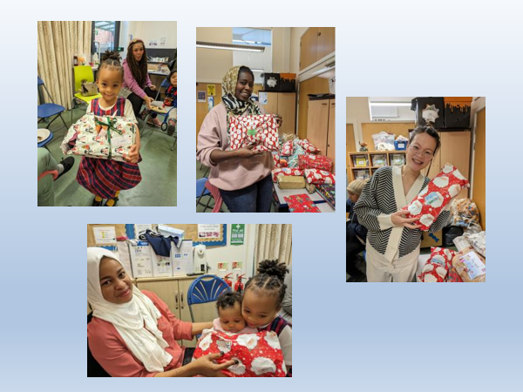
Christmas presents were given out to families across Leeds. The parents and children were so grateful, thank you so much for your kindness and generosity. It made a massive difference.

