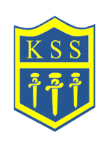

**Assessments 2022, 2023 & 2024**

**KSS compared to Leeds and National schools**

**Early Years Foundation Stage**

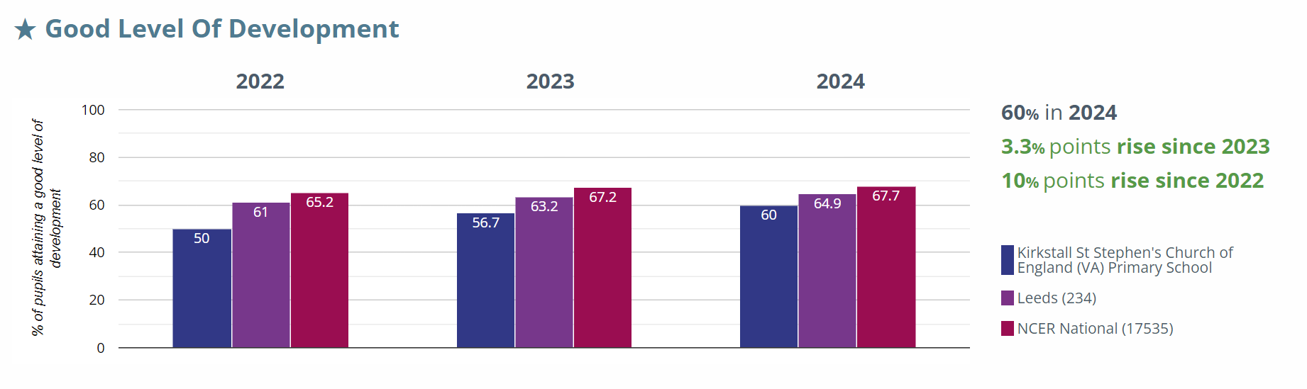

**Phonics**

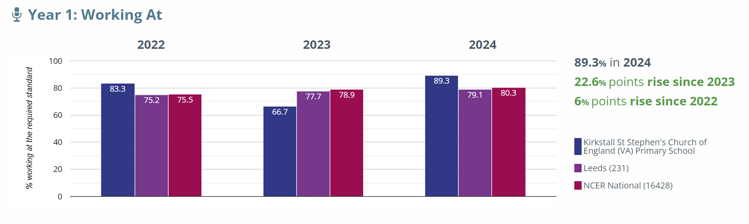

**KS2 Assessments**

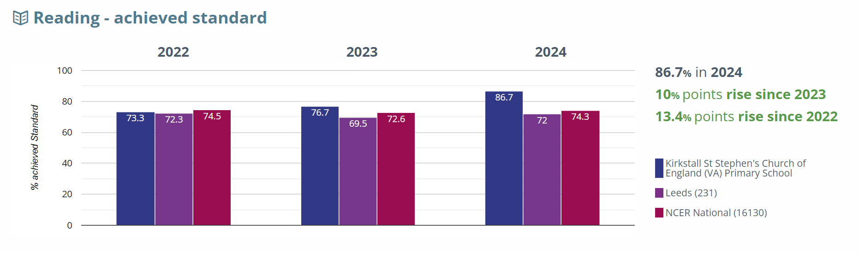

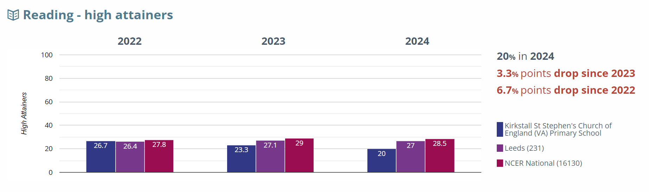

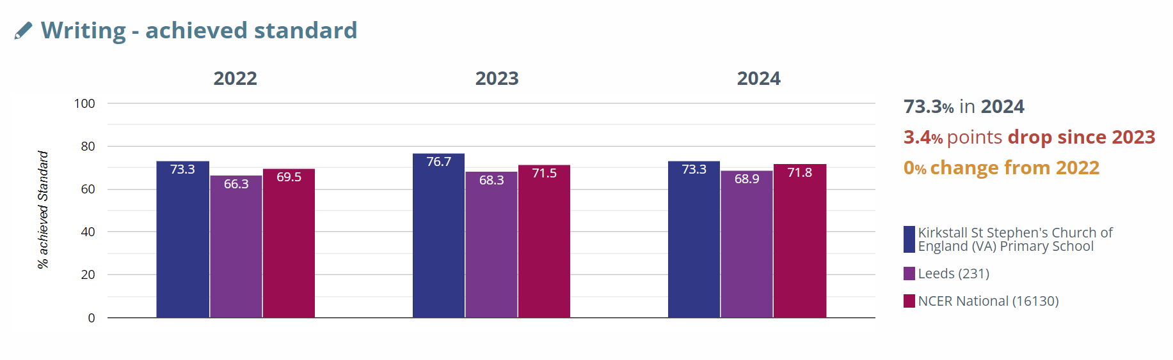

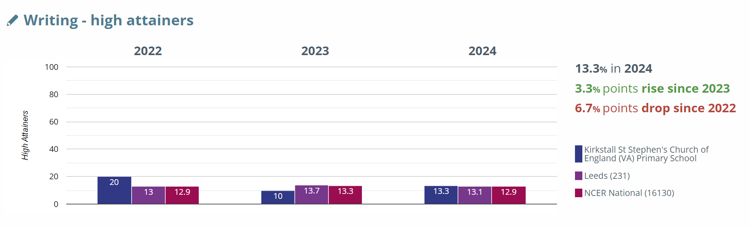

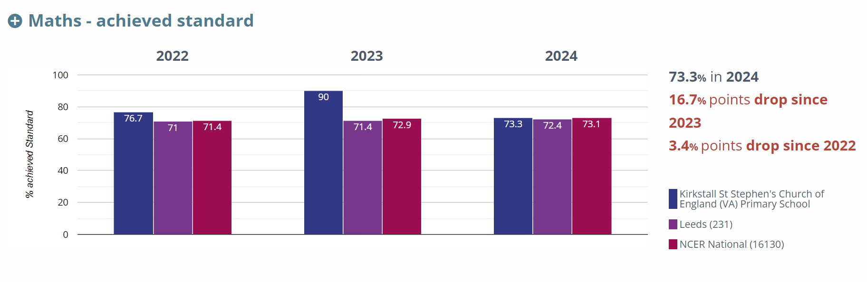

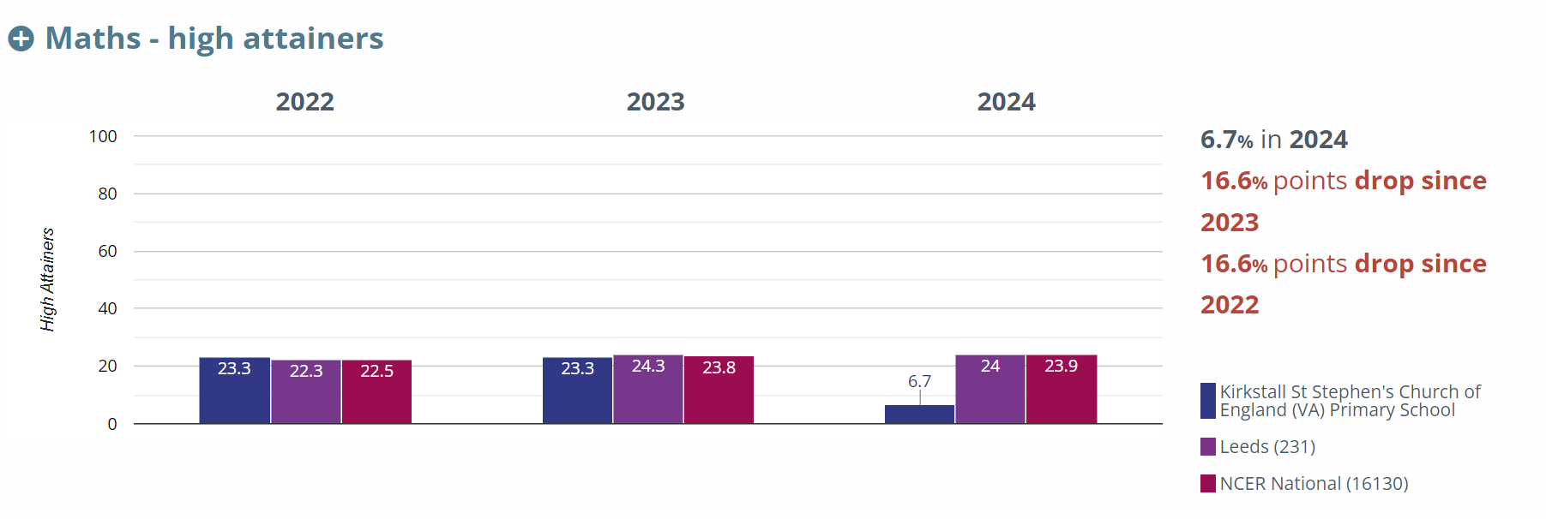

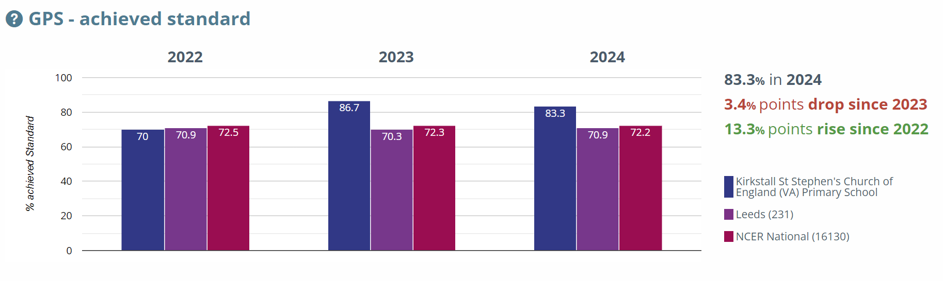

**GPS= Grammar, Punctuation and Spelling**

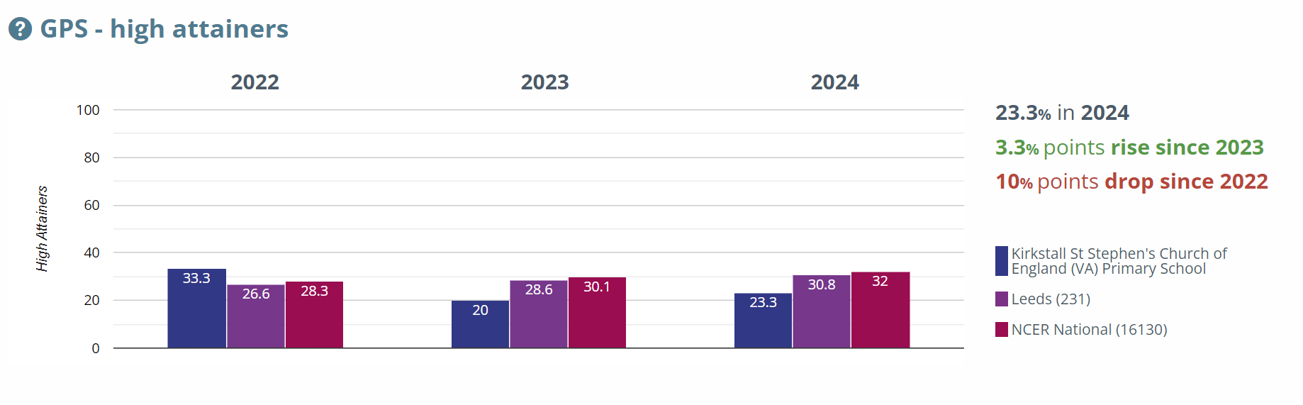

**RWM= Reading/Writing/Mathematics combined**

