

 | Kirkstall St Stephen’s  Church of England Aided (VA) Primary School  Headteacher: Mr P Sheppard  http://www.kirkstall-st-stephens.leeds.sch.uk/  contactus@kirkstallss.net | Morris Lane  Kirkstall  Leeds  LS5 3JD  T:0113 382 1960  F:0113 382 1961
Dear Parents and Carers, June 2022

RE: Dojo App and home learning

In the next few weeks, you will be getting an email notification from me inviting you to join your child’s class by downloading the Dojo App. Please look out for this email and let school know if you do not receive it this by the 15th of July). We are encouraging all of our pupils to use Class Dojo.

Once you receive your invite, please follow the simple instructions to join your child’s class. There are two options available for accessing Class Dojo. You could access the platform via a website link (https://www.classdojo.com/en-gb/?redirect=true) OR you can download the Class Dojo App. Both work exactly the same way, so please choose whatever is easiest for you. When you have joined your child’s class, there will be an option for your child to make/redesign their own monster. (please see attached sheets for more information).

The dojo app will be used for whole school and class updates, letters and weekly homework tasks. Please add photographs and homework to your child’s ‘portfolio’. Please do not use the private messaging service as this is only used for sending messages out (e.g. a bump note) so messages to a teacher could get missed. If you would like to speak to the teacher, please do so face to face or ring the office to arrange a telephone appointment.

If you have any problems setting this up, please do inform me and I can talk you through it.

With thanks

Miss Barnett

(Reception Teacher and Deputy Head)

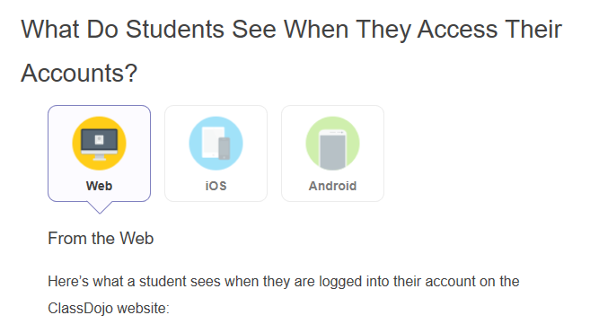

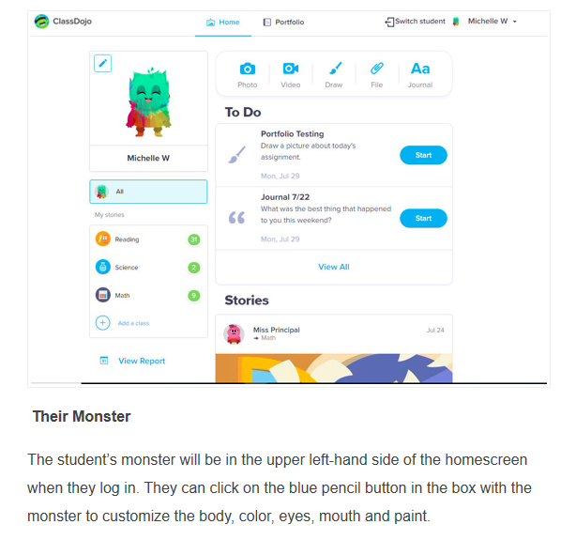

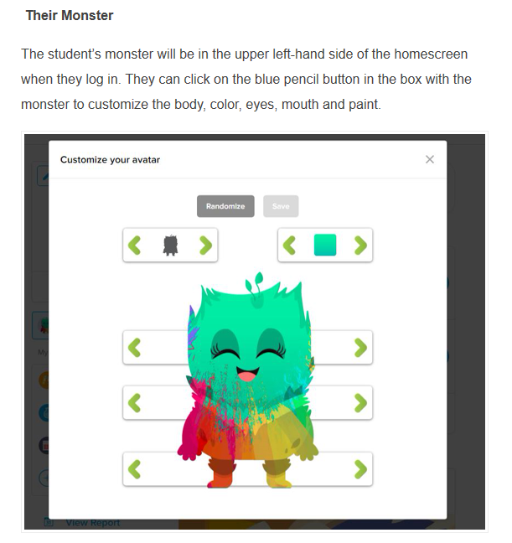
If you would like any more information or are having trouble accessing the invite, please don’t hesitate to contact school directly and a message will be passed on to your child’s class teacher.

Many Thanks

Miss Barnett

Reception Class Teacher and Deputy Head

